**DATA FLOW DIAGRAM**

The Data Flow Diagram of the proposed system. The superadmin register the student and after the succesfull registration the student credentials will send to student via email. Students can now signin in and the system will generate a permanent QR code for them. The student Qrcode need to present at the admin of the room, and the admin will choose a location from database before scanning the qrcode, note the admin can change location because who doesn’t now where the admin will be assign, after selecting a location, the admin will now scan the qrcode and the system automaticaly get the student information to insert at the database. Admin can also request a reports through the system and the system will give a excel reports of who students enter that location. Also the superadmin can request also reports from the system for each location.

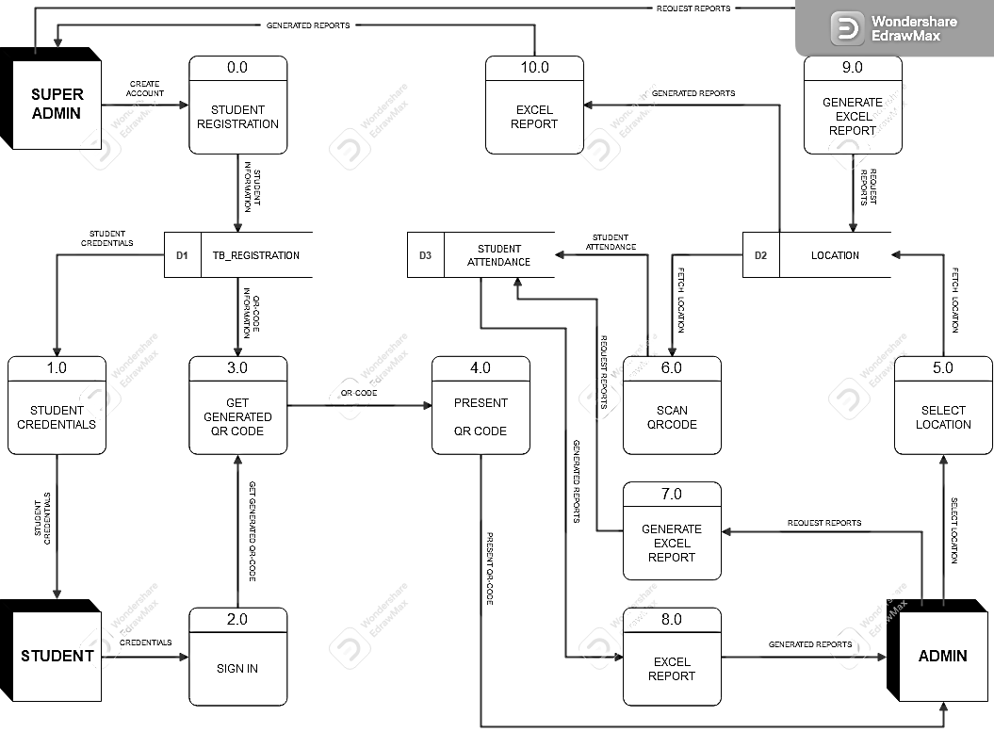

**FLOWCHART**

